Investern- Personal Finance ManagingWebsite

**Submitted in partial fulfillment of the requirement for the award of Degree of Bachelor of Technology in**

**Computer Science & Engineering**

**Submitted to:**



**RAJIV GANDHI PRODYOGIKI VISHWAVIDYALAYA, BHOPAL (M.P.)**

**Submitted by:**

**Devanshu Das (0808CS191060)**

**Priyanshi Pundir (0808CS191148)**

**Sanskar Babel (0808CS191168)**

**Skand Sharma (0808CS191178)**

**Under the Supervision of:**

**Ms. Namarata Atre**



**IPS ACADEMY, INDORE**

**INSTITUTE OF ENGINEERING & SCIENCE**

**(A UGC AUTONOMOUS INSTITUTE, AFFILIATED TO RGPV, BHOPAL)**

**DEPARTMENT OF COMPUTER SCIENCE & ENGINERRING**

**SESSION: 2021-22**

**IPS Academy, Indore**

**Institute of Engineering and Science**

**(A UGC Autonomous Institute, Affiliated to RGPV, Bhopal)**

**Department of Computer Science & Engineering**

**2021-22**



“Investern- Personal Finance Managing Website”

**Guided by: - Submitted by: -**

Ms. Namarata Atre Devanshu Das (0808CS19060)

Priyanshi Pundir (0808CS191148)

Sanskar Babel (0808CS191168)

Skand Sharma (0808CS191178)

**IPS Academy, Indore**

**Institute of Engineering and Science**

**(A UGC Autonomous Institute, Affiliated to RGPV, Bhopal)**

**Department of Computer Science & Engineering**

**2021-22**



CERTIFICATE

This is to certify that Project -I entitled

“Investern- Personal Finance ManagingWebsite”

has been successfully completed by the following students

Devanshu Das

Priyanshi Pundir

Sanskar Babel

Skand Sharma

Ms. Namarata Atre Dr. Neeraj Shrivastava

**SUPERVISOR** **HOD CSE**

Dr. Archana Keerti Chowdhary

**PRINCIPAL**

**ACKNOWLEDGEMENT**

SI would like to express my heartfelt thanks to my Supervisor Ms. Namarata Atre**,** for her guidance, support, and encouragement during the course of my study for B.Tech.(CSE) at IPS Academy, Institute of Engineering & Science, Indore. Without her endless effort, knowledge, patience, and answers to my numerous questions, this Project would have never been possible. It has been great honor and pleasure for me to do Project under his supervision.

My gratitude will not be complete without mention of **Dr. Archana Keerti Chowdhary, Principal, IPS Academy, Institute of Engineering & Science** and **Dr. Neeraj Shrivastava ,** **HOD CSE, IPS Academy, Institute of Engineering & Science** for the encouragement and giving me the opportunity for this project work.

I also thank my friends who have spread their valuable time for discussion/suggestion on the critical aspects of this report. I want to acknowledge the contribution of my parents and my family members, for their constant motivation and inspiration.

Finally I thank the almighty God who has been my guardian and a source of strength and hope in this period.

**Devanshu Das (0808CS191060)**

**Priyanshi Pundir (0808CS191148)**

**Sanskar Babel (0808CS191168)**

**Skand Sharma (0808CS191178)**

# TABLE OF CONTENTS

Table of Contents

CHAPTER 1 - INTRODUCTION 8

CHAPTER 2 – PROBLEM STATEMENT 9

2.1 PROBLEM STATEMENT 9

2.2 OBJECTIVES 9

2.3 SCOPE 10

2.3.1 User 10

2.3.2 System 10

2.4 LIMITATION OF WORK 10

CHAPTER 3 – LITERATURE REVIEW 12

3.1 LITERATURE REVIEW 12

3.2 HOPBOOKING AUDITORIUM & HALL MANAGEMENT SYSTEM (HOPBOOKING) 12

CHAPTER 4 - METHODOLOGY 13

4.1 INTRODUCTION 13

4.2 ITERATIVE AND INCREMENTAL MODEL 13

4.2.1 Initial Planning Phase 14

4.2.2 Planning Phase 14

4.2.3 Requirement Phase 16

4.2.4 Analysis and Design 16

4.2.5 Implementation and Testing 16

4.2.6 Evaluation 17

4.2.7 Deployment 17

4.3 SOFTWARE AND HARDWARE REQUIREMENT 18

4.3.1 Hardware Requirement 18

4.3.2 Software Requirement 19

4.4 FRAMEWORK AND SYSTEM DESIGN 20

4.4.1 Framework 20

4.4.2 Entity Relationship Diagram (ERD) 22

4.4.3 Context Diagram (CD) 24

4.4.4 Data Flow Diagram (DFD) 25

Process 1.0 Registration 26

Process 2.0 Login 26

Process 3.0 Manage Profile 26

Process 4.0 Booking 26

Process 5.0 Manage Auditorium & Hall 26

Process 6.0 Report 26

4.4.5 Data Flow Diagram (Level 1) 28

CHAPTER 5 – IMPLEMENTATION PHASE 13

5.1 LANGUAGE USED AND ITS CHARACTERISTICS 13

5.2 MODULES 13

5.3 SNAPSHOTS  14

CHAPTER 6 – TESTING METHOD 13

6.1 TESTING METHOD 13

6.2 TEST CASES 13

CHAPTER 7 - CONCLUSION 46

7.1 CONCLUSION 46

7.2 ACHIEVEMENT OF THE PROJECT 46

REFERENCES 47

**ABSTRACT**

Many organizations have their own system to record their income and expenses, which they feel is the main key point of their business progress. It is good habit for a person to record daily expenses and earning but due to unawareness and lack of proper applications to suit their privacy, lacking decision making capacity people are using traditional note keeping methods to do so. Due to lack of a complete tracking system, there is a constant overload to rely on the daily entry of the expenditure and total estimation till the end of the month.

Personal finance is a term that covers managing your money as well as saving and investing. It encompasses budgeting, banking, insurance, mortgages, investments, retirement planning and tax and estate planning. The term often refers to the entire industry that provides financial services to individuals and households and advises them about financial and investment opportunities. In our project we are just covering expense and investment tracking.

# CHAPTER 1- INTRODUCTION

**1.1 INTRODUCTION**

This chapter presents an introduction of the project proposal, Many organizations have their own system to record their income and expenses, which they feel is the main key point of their business progress. It is good habit for a person to record daily expenses and earning but due to unawareness and lack of proper applications to suit their privacy, lacking decision making capacity people are using traditional note keeping methods to do so. Due to lack of a complete tracking system, there is a constant overload to rely on the daily entry of the expenditure and total estimation till the end of the month. Investern is an idea that covers managing your money as well as saving and investing. It encompasses budgeting, banking, insurance, mortgages, investments, retirement planning and tax and estate planning. The term often refers to the entire industry that provides financial services to individuals and households and advises them about financial and investment opportunities. In our project we are just covering expense tracking.

The project titled “Personal Finance Manager” is a website for monitoring and controlling the personal expense and investment of an individual. The project “Personal Finance Manager” is developed in HTML, CSS and PHP which is mainly focuses on the basic personal finance management like tracking expense and investment tracking.

Key Takeaways

* Few schools have courses in how to manage your money, so it is important to learn the basics through free online articles, courses, blogs, podcasts, or at the library.
* Smart personal finance involves developing strategies that include budgeting, creating an emergency fund, paying off debt, using credit cards wisely, saving for retirement, and more.

Being disciplined is important, but it’s also good to know when to break the rules for example, young adults who are told to invest 10% to 20% of their income for retirement may need to take some of those funds to buy a home or pay off debt instead.

# 

# CHAPTER 2- PROBLEM STATEMENT

**2.1 PROBLEM STATEMENT**

Before getting the idea of making this website we were familiar with other website and application present in the market but by using it with time we have encountered several problems with these website.

The problems that we have encountered are:

* Not Affordable.
* Many scams involved.
* Not value for money.
* Corporate centric.
* Expense tracker website/application lacks investment and budget planning.
* Biased towards the sponsorship.

Keeping in mind all the problems that we have encountered by using familiar website and application which do have pretty nice user interface and wide reach to people but lacks basic features which are pretty needed in our day to day life.

In existing, we need to maintain the Excel sheets, CSV etc. files for the user daily and monthly Income and expenses. In existing, there is no as such complete solution to keep a track of its daily expenditure easily. To do so a person as to keep a log in a diary or in a computer, also all the calculations needs to be done by the user which may sometimes results in errors leading to losses.

So we have decided to make an efficient website in which we will resolve all the problems that we are facing and mentioned above with a nice interface.

# 2.2 OBJECTIVES

The aim and objective of the project is to fully manage and keep tracking the daily expenditure. The following is the benefits that come with the Personal Expense Tracker:

* Minimize manual effort with daily record of expenditures and incomes.
* Immediate and easy retrieval of report.
* Secured and transparent data.
* Help in decision making with related results.
* Help in preparing wish list for pre planning your expenses.

# SCOPE

The scope of this project consists of one users which is User.

# User

* + - 1. It has User login who is has the authority of the system and he is will be managing and handling the entries of the expenses.
      2. User can add and delete the entry and updates in the system.
      3. User will also be able to retrieve the expense report.

# System

* + - 1. The system keeps track of all the entries and updates made by the user

2.3.2.2 The system also allows report on demand whenever the user wants.

# 2.4 LIMITATION OF WORK

**a) Only Expense tracker**

This project only provides to manage daily expense of an person and track his or her expense in Investern. The system will not provide investment tracking of that person in this software as of now.

# CHAPTER 3- LITERATURE REVIEW

**3.1 LITERATURE REVIEW**

|  |  |  |  |
| --- | --- | --- | --- |
| Apps  Features | Expense Manager by Bishinews | Hello Expense by Alan L | Personal Expense Tracker |
| Ease of Use | Medium | Low | High |
| Backup/Restore | Yes | Yes | No |
| Expense/Income | Yes | Yes | Yes |
| Wish List | Yes | No | Yes |
| Decision Making | No | No | Yes |
| Notification | Yes | No | Yes |
| Focus Group | Personal | Finance & Business | Personal |
| Password Protected | No | No | Yes |
| Detailed Report | No | No | Yes |

We found various similar product that have already been developed in the market. Unlike all those products Personal Expense Tracker (PET) provides security and graphical results. We provide the users to enter their wish-list before any purchase. It generates notification to notify user about their timely entry.

In order to complete our task, we used Android platform to build a portable, handy product that can run in Android phone. We used Android studio to build our application. The major language we used for scripting was HTML, CSS & PHP for producing better layout. We used MYsql to implement database. On comparing our project with other similar applications we came to conclude with the following:

**Table 3. 1. Comparison Table**

# CHAPTER 4- METHODOLOGY

### REQUIRED TOOLS

During the development of the system, we required various tools essential for the project. Our projected could not have been completed without these tools. Here are some list of tools used in the project.

* + 1. Notepad++ Text Editor: For basic text editing
    2. Android Studio: For application development
    3. Inkscape: For generating icons
    4. Adobe Photoshop: For generating assets
    5. Ms-Word: For preparing report
    6. Ms-Visio: For UML diagrams
    7. Ms-Excel: For Gantt chart

### APPROACH USED

Having a proper track to our expenses helps us to organize our finance which is actually a very difficult task. Looking through our expenses at regular interval allow us to review our spending habit.

Writing records of our expense in paper is a traditional way. In the world driven by technology, it is not a right measure or choice indeed. It is difficult to relate our present expenses with past when data need to be reviewed and it is even not secure.

So with this particular application Personal Expense Tracker, we have tried to feature several concepts that the user can fully track all of his/her expense as compared to present system in practice. Personal Expense Tracker is a technology driven approach where user have to log in to track their spending and earnings.

### DESIGN

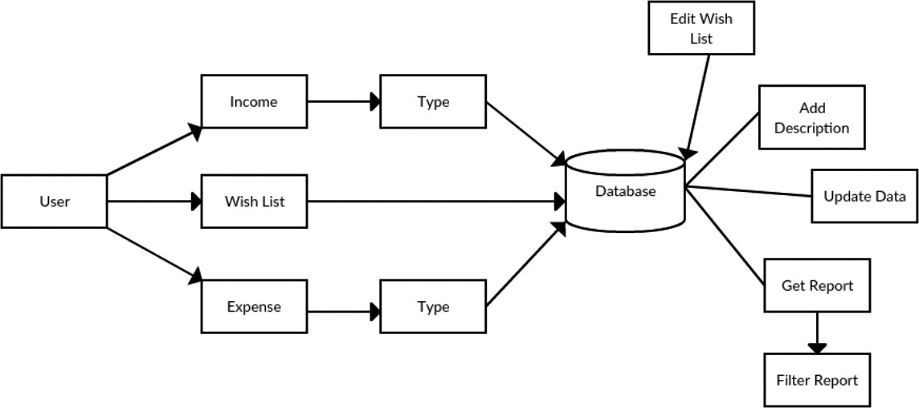

**Figure 3. 1. Block Diagram**

Upon using this application user are provided with three options for data entry namely – Income, Expense and wish list. If he/she selects income or expense he/she would be provided with its types and subtypes. For wish list only items can be inserted. These data would be saved onto database according to their respective category.

The saved data can later be altered if the user wants to do so. Altering here means adding description, changing wish list updating data etc. User can also view the result. They can also filter result to see the required content only.

#### USE CASE DIAGRAM

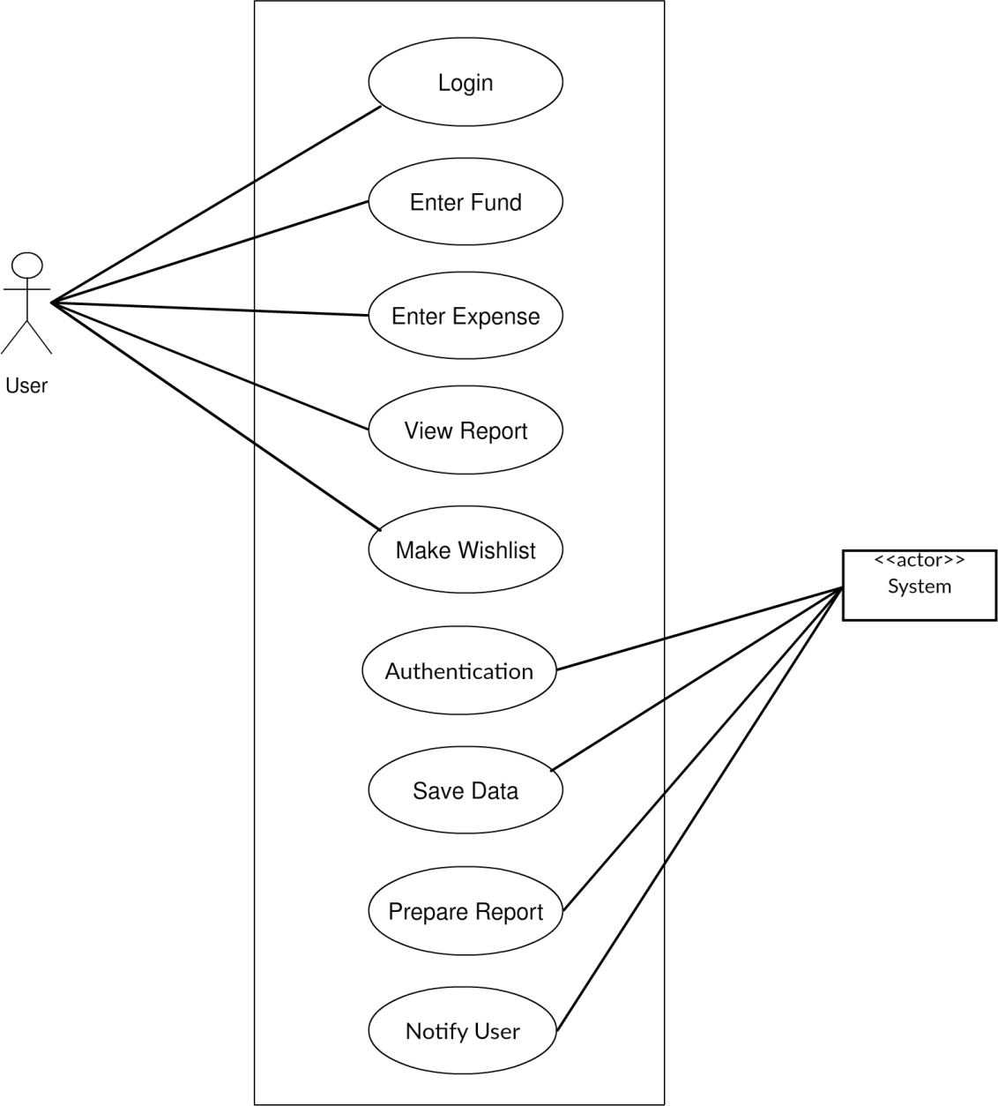

**Figure 3. 2. Use Case Diagram for Personal Expense Tracker**

Personal Expense Tracker (PET) lets you have your privacy, you must login to open this application. Users are authenticated upon each entry so that they can enter their expenses and income which will be recorded by the system. System generates meaningful output form entered data.

**Use Case UC1: Login**

**Primary Actor:** User

**Secondary Actor:** System

**Stakeholders:**

**User:** Wants to update transaction.

**Preconditions:** User must login.

**Post conditions:** Transaction is saved.

**Basic flow:**

* User login to system using password.
* User selects appropriate option from the menu.

**Alternate flow:**

* At any time, user enters a wrong password then system notifies.
* User can select the option forgot password.

**Use Case UC2: Enter Fund**

**Primary Actor:** User

**Secondary Actor:** System

**Stakeholders:**

**User:** Wants to save budget amount in fund category.

**Preconditions:** User have been logged in.

**Post conditions:** New fund is saved.

**Basic flow:**

* User selects category.
* Budget amount is updated.

**Alternate flow:**

* At any time, system fails, system regains previous status.
* System displays the error.

**Use Case UC3: Enter Expense**

**Primary Actor:** User

**Secondary Actor:** System

**Stakeholders:**

**Preconditions:** User have been logged in.

**Post conditions:** New expense is saved.

**Basic flow:**

* User selects category.
* Expense amount is updated.

**Alternate flow:**

* At any time, system fails, system regains previous status.
* System displays the error.

**Use Case UC4: View Report**

**Primary Actor:** User

**Secondary Actor:** System

**Stakeholders:**

**Preconditions:** User have been logged in.

**Post conditions:** User gets informed about the transactions.

**Basic flow:**

* User selects category and time frame.
* Selected result is displayed.

**Alternate flow:**

* At any time, system fails, system regains previous status.
* System displays the error.

**Use Case UC5: Make Wishlist**

**Primary Actor:** User

**Secondary Actor:** System

**Stakeholders:**

**Preconditions:** User have been logged in.

**Post conditions:** New wishlist item is saved.

**Basic flow:**

* User adds wishlist items with approximate amount.
* The targeted amount is shown.

**Alternate flow:**

* At any time, system fails, system regains previous status.
* System displays the error.

**Use Case UC6: Authentication**

**Primary Actor:** System

**Stakeholders:**

**User:** Wants to use service.

**Preconditions:** User login to system.

**Post conditions:** Password is verified and authorized user is given access

to system.

**Basic flow:**

* User login to system using password.
* System checks password and authorized user can access service.

**Alternate flow:**

* At any time, system fails, system logs the error.
* Error message is displayed.

**Use Case UC7: Save Data**

**Primary Actor:** System

**Preconditions:** Transactions are provided.

**Post conditions:** Display saved message.

**Basic flow:**

* The user enters the transaction amount with category.
* System saves the amount to the category and display saved message.

**Alternate flow:**

* At any time, system fails, system regains previous status.
* Error message is displayed.

**Use Case UC8: Prepare Report**

**Primary Actor:** System

**Preconditions:** Transactions are provided.

**Post conditions:** Display the report graphically.

**Basic flow:**

* The user selects the result category.
* System prepares report.
* Display prepared report graphically.

**Alternate flow:**

* At any time, system fails, system regains previous status.
* Error message is displayed.

**Use Case UC9: Notify User**

**Primary Actor:** System

**Preconditions:** Notify user setting must be enabled.

**Post conditions:** Alert message is displayed.

**Basic flow:**

* System generates notification message.
* Display message in notification bar.

**Alternate flow:**

* At any time, system fails, system regains previous status.
* Error message is displayed.

#### SYSTEM SEQUENCE DIAGRAM (SSD)

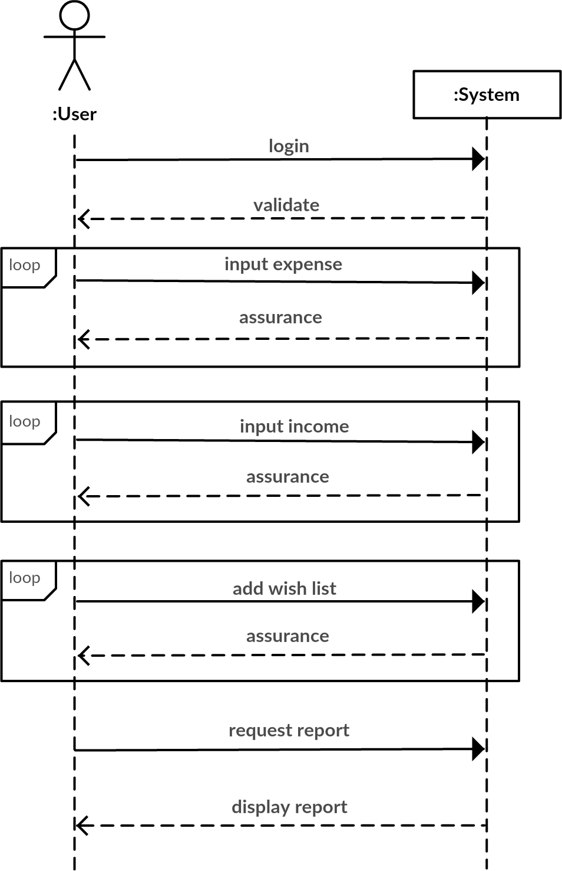

**Figure 3. 3. System Sequence Diagram (SSD)**

User logins and the system validates to checks for the right user. After login process is completed users can enter their expense, which is recorded by system under right category. Multiple data can be saved by users. The same process applies for income. Upon successful data save system assures users about the action. User can also save their wish list and do have right to modify them in future if necessary.

#### ENTITY RELATIONSHIP DIAGRAM (ERD)

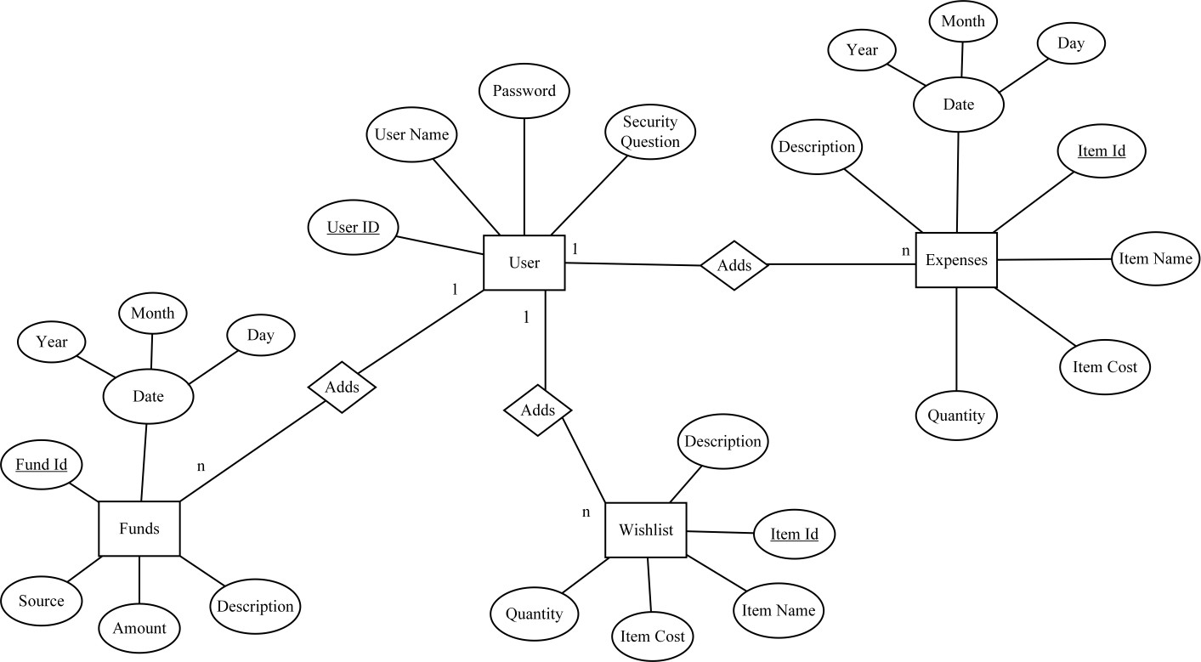

**Figure 3. 4. Entity Relationship Diagram**

#### SEQUENCE DIAGRAM

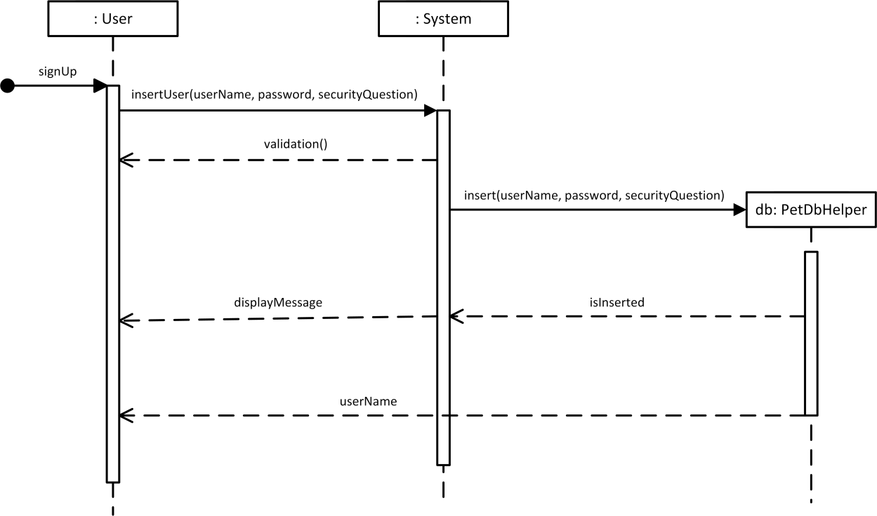

**Figure 3. 5. Sequence Diagram of SignUp**

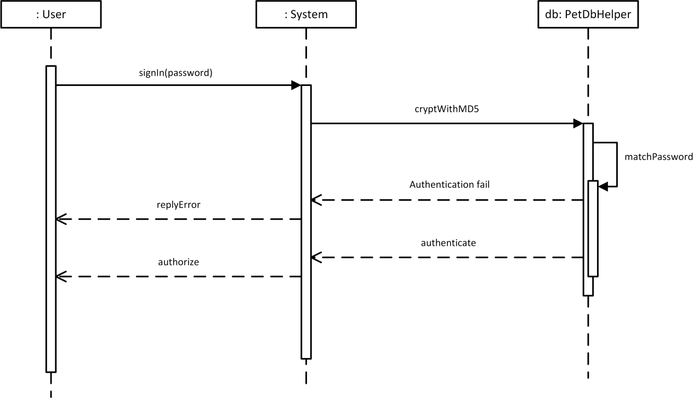

**Figure 3. 6. Sequence Diagram of SignIn**

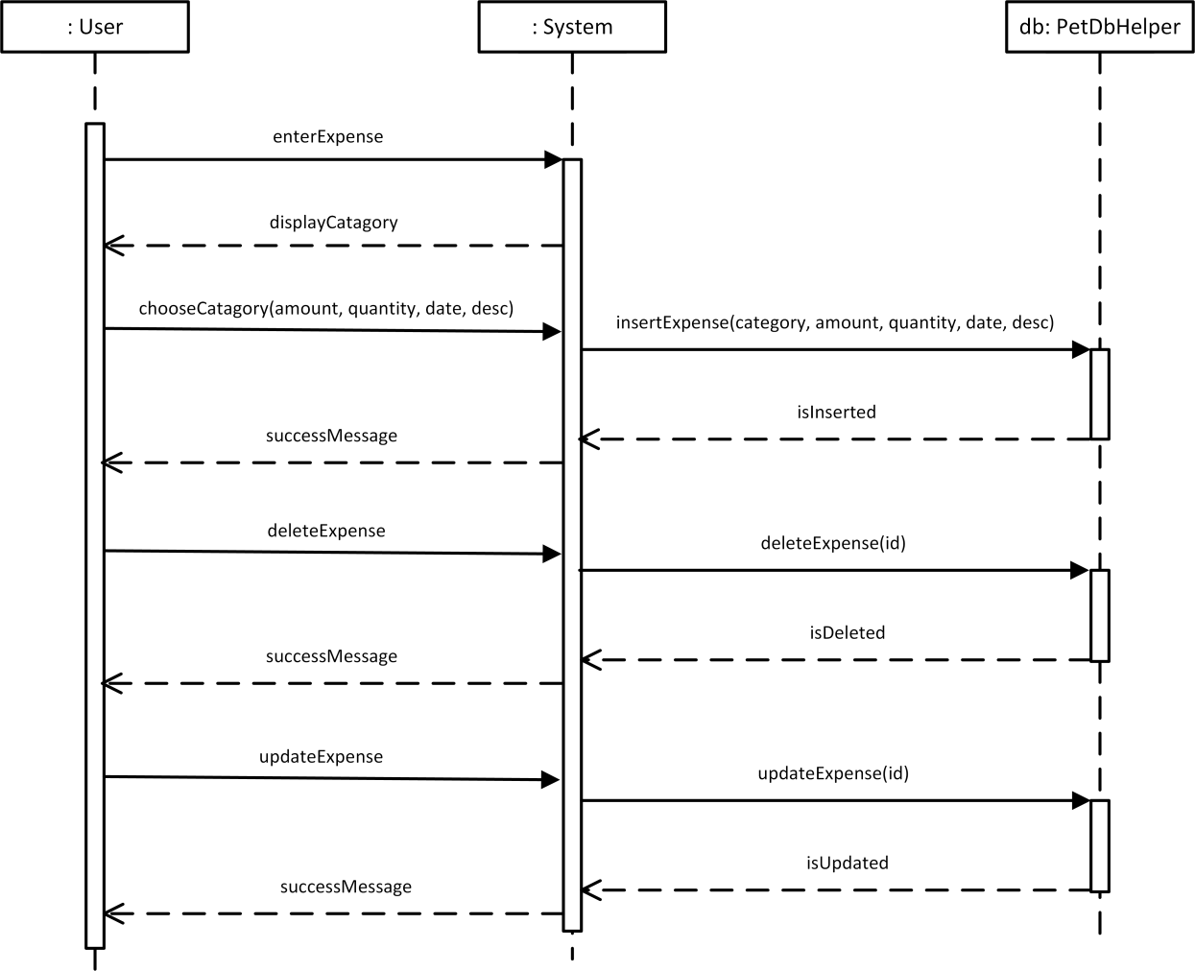

**Figure 3. 7. Sequence Diagram of Expense**

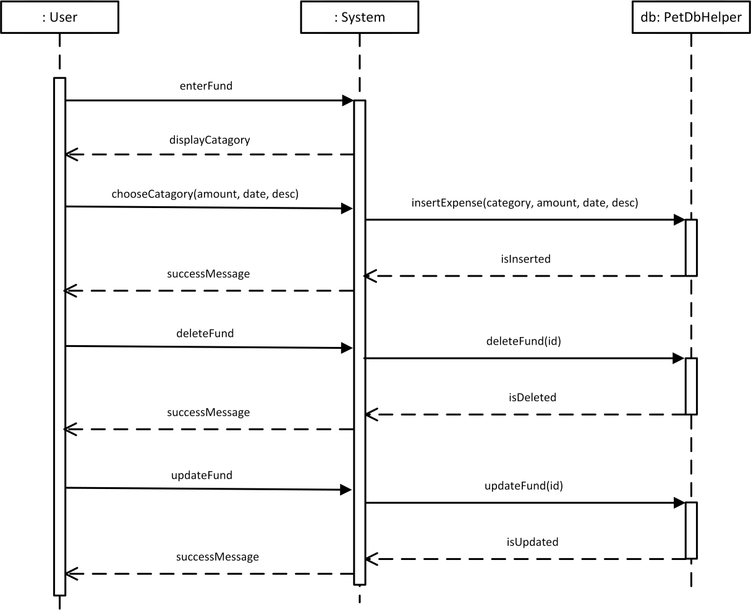

**Figure 3. 8. Sequence Diagram of Fund**

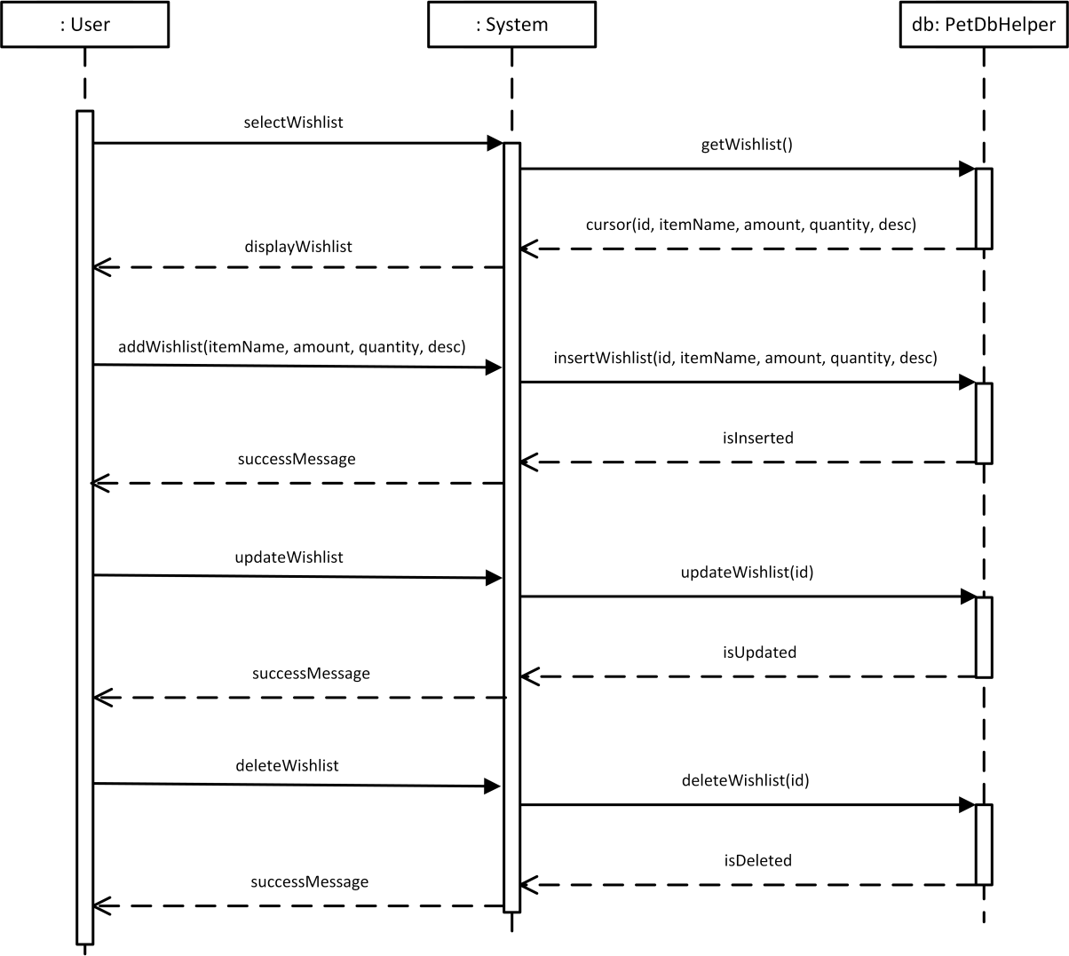

**Figure 3. 9. Sequence Diagram of Wishlist**

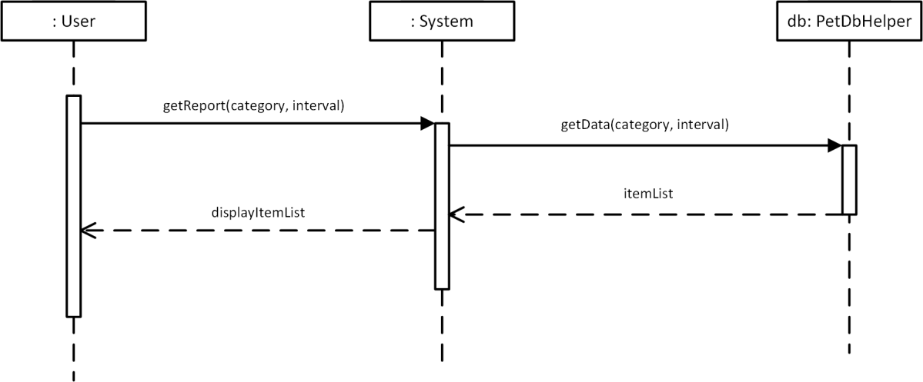

**Figure 3. 10. Sequence Diagram of Report**

#### DESIGN CLASS DIAGRAM (DCD)

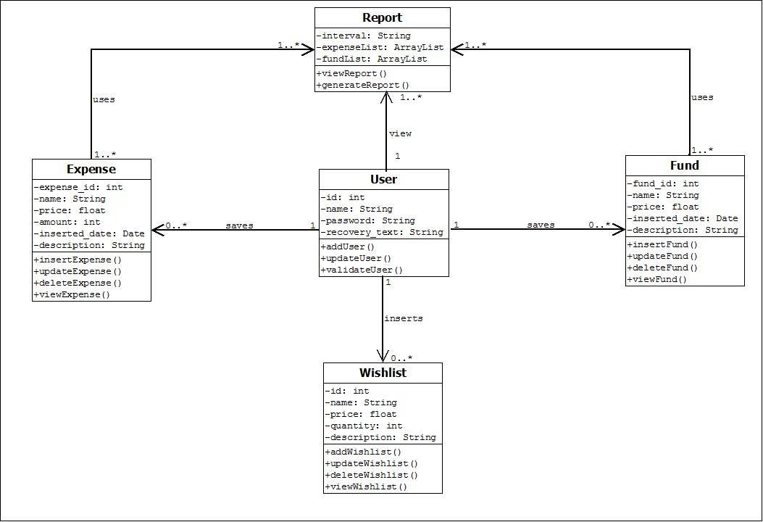

**Figure 3. 11. Design Class Diagram**

# SOFTWARE AND HARDWARE REQUIREMENT

In the making of this project, software and hardware tools are very important and essential. The system cannot be developed successfully without these software and hardware requirements.

# Hardware Requirement

|  |  |  |
| --- | --- | --- |
| **No.** | **Hardware** | **Description** |
| 1. | Laptop | Model: Lenovo G-50  CPU: Intel®Core™i3 OS: Windows 10 Pro  Function: To develop the system and make the  documentation. |
| 2. | Printer | Function: To print all the needed document and report. |
| 3. | USB pen-drive | Function: To store all the data and act as a backup for  the project. |

**Table 3.1 Hardware Requirement**

# 4.3.2 Software Requirement

|  |  |  |
| --- | --- | --- |
| **No.** | **Software** | **Description** |
| 1. | Notepad++ | Tools used for developing the code for function  and interface. |
| 2. | MySQL | System database application. |
| 3. | PHPmyadmin | Tools used for creating, modifying or deleting  databases, tables, fields or rows. |
| 4. | Xampp | Local server to run and test the system and the  database connection. |
| 5. | Google Chrome | Tools used as a platform to run the system. |
| 6. | Adobe Reader | Tools used to view documents, journal and  research papers. |
| 7. | Microsoft Office 2010   * Microsoft Word 2010 * Microsoft PowerPoint 2010 * Microsoft Visio 2013 | Tools used for documentation of the project, creating report, presentation slide and draw diagrams. |

**Table 3.2 Software Requirement**

**CHAPTER 5- IMPLEMENTATION PH**

**ASE**

**5.1 IMPLEMENTATION PHASE**

This chapter provides an overview of the implementation process. So, the interface can occupy the full screen in any kind of device.

**5.2 LANGUAGE USED AND ITS CHARACTERSTICS**

* HTML

HTML stands for hypertext markup language. It is very useful to make web pages and very easy to learn. Hypertext Markup file is a text file containing small markup tags. These marks up tags tell the browser how to display a web page.

* It is the language that can be easily understood and can be modified.
* It provides a more flexible way to design web pages along with the text.
* Links can also be added to the web pages so it helps the readers to browse the information of their interest.
* You can display HTML documents on any platform such as Macintosh, Windows, and Linux, etc.
* Graphics, videos, and sounds can also be added to the web pages which give an extra attractive look to your web pages.
* CSS

CSS stands for Cascading Style Sheets. It describes how Html elements should be displayed on screen. It is a powerful tool for web designers to change the design and control over web pages that how it should be displayed. It is supported by all browsers and is designed primarily to separate the document content from document presentation.

* A style rule consists of a selector component and a declaration block component.
* The selector is used to point to the HTML component which you want to get styled.
* Inside the declaration block, one or more declarations are contained along with semicolons.
* Every declaration which is put has a CSS property name, a semicolon, and a value. For example, color is the property, and the value is red in color. Font size is the property, and the 15px is the value.
* CSS declaration ends with a semicolon, and these blocks are surrounded by curly braces.
  1. **SNAPSHOTS**
* Home Page

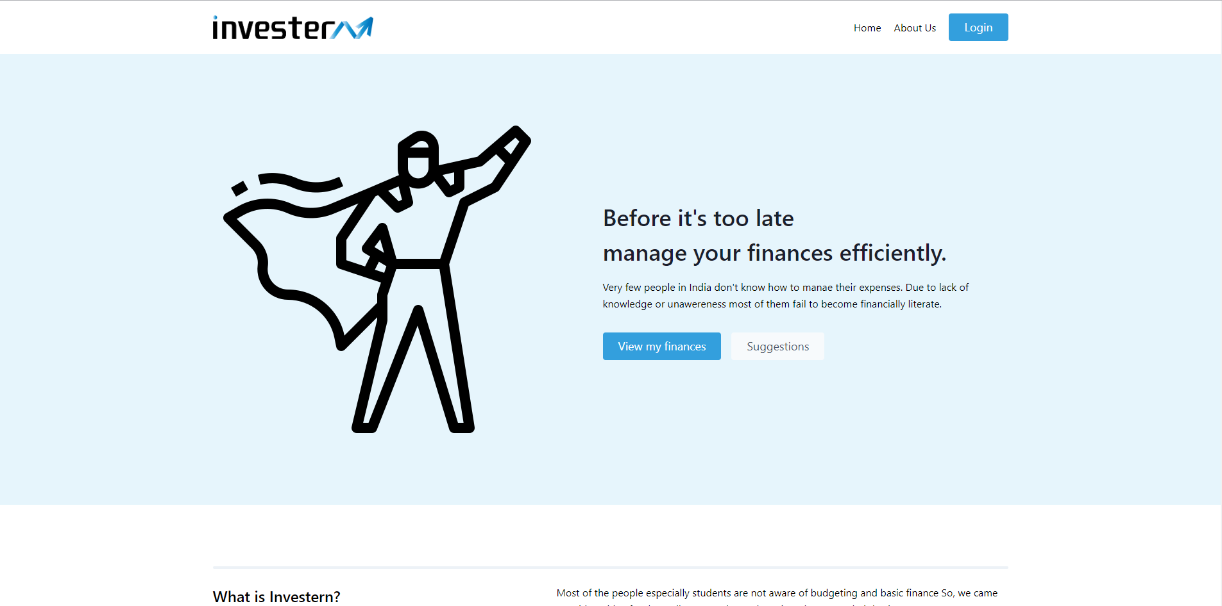

* Dashboard

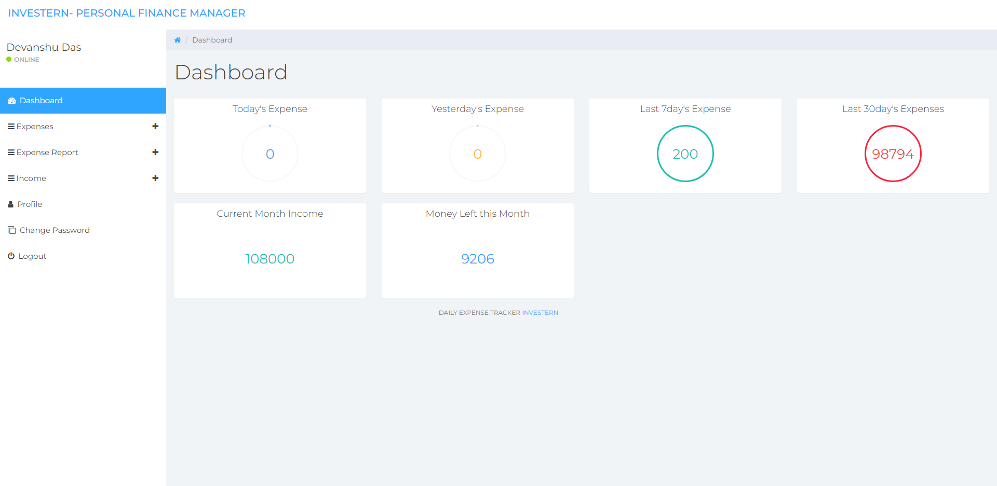

* Enter Expense

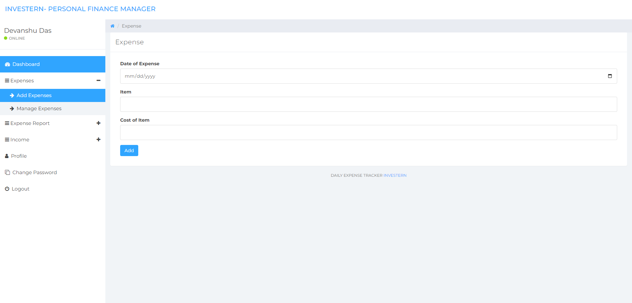

* Manage Expense

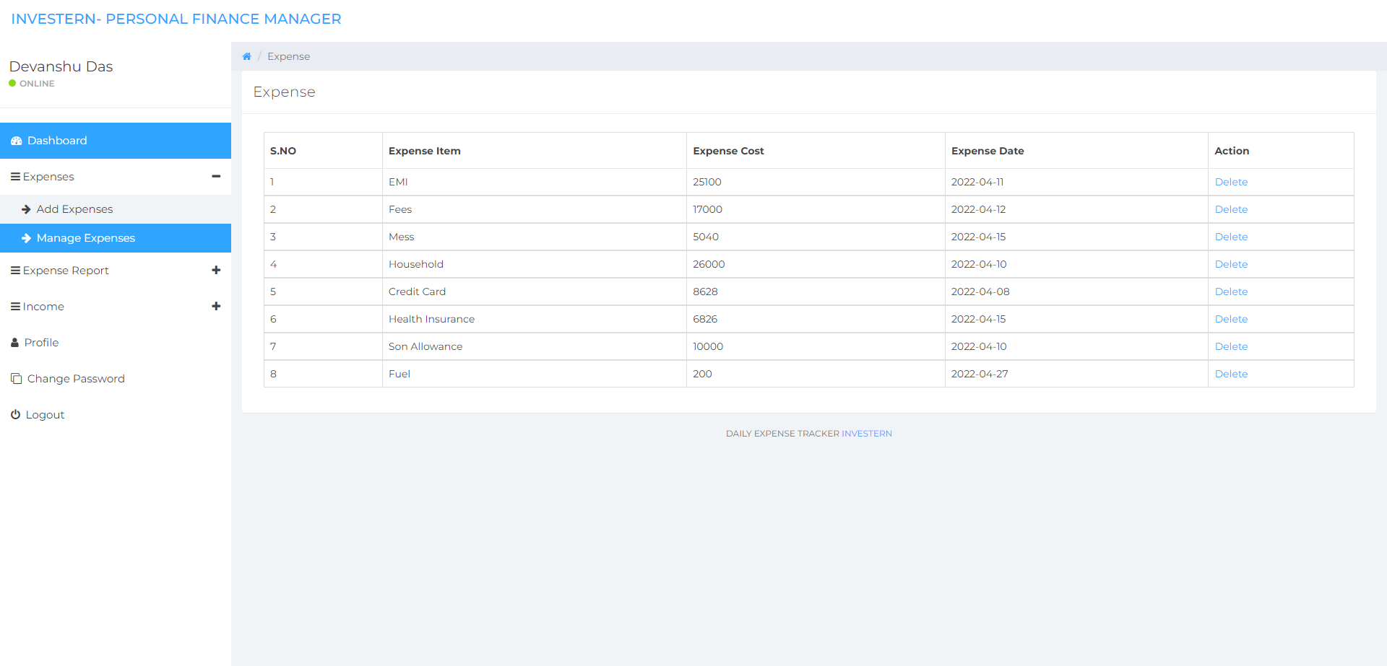

**CHAPTER 6- TESTING METHOD**

This chapter elaborates the test process of the application and shows the result of testing. This chapter describes the software testing concerns of the project. It covers different testing approaches that adopted in the project and some of the techniques applied to realize this process. The chapter first provides an overview of software testing. Then, the processes of each adopted testing approaches are discussed in depth.

Software testing is a critical element of software quality assurance and represents the ultimate review of specification, design and code generation.

### OBJECTIVE OF TESTING

* Testing is a process of executing a program with the intent of finding an error.
* A good test case is one that has a high probability of finding an as- yet undiscovered error.
* A successful test is one that uncovers an as-yet-discovered error.

### TEST CASES

|  |  |  |  |
| --- | --- | --- | --- |
| Test  Case ID | Purpose | Test Cases | Result |
| TC1 | Authentication | User name with length  less than 2 characters | User name cannot be  less than 2 characters |
| TC2 | Authentication | Valid user name with  minimum 2 characters | User name accepted |
| TC3 | Authentication | User name left blank | User name cannot be  less than 2 characters |
| TC4 | Authentication | Password field left  blank | Password cannot be  empty |

|  |  |  |  |
| --- | --- | --- | --- |
| Test  Case ID | Purpose | Test Cases | Result |
| TC5 | Authentication | Password with length  less than 4 characters | Password cannot be  less than 4 characters |
| TC6 | Authentication | Minimum 4 characters  valid password | Password accepted |
| TC7 | Authentication | Password and Confirm Password did not  match | Please enter same password |
| TC8 | Authentication | Confirm Password  field left blank | Please enter same  password |
| TC9 | Authentication | Security question with length less than 3  characters | Security question cannot be less than 3  characters |

**Table 4. 1 Table of Test Cases for SignUp**

# 

# CHAPTER 7- CONCLUSION

**7.1. CONCLUSION**

First of all, we gained additional skills in the HTML programming language. We also learned how to use a lot of the components in it. Finally, this project allowed us to use MySql skills acquired during our studies. We have been able to complete our project according to our plan in the given timeline.

From this project, we are able to manage and keep tracking the daily expenses as well as income. While making this project, we gained a lot of experience of working as a team. We discovered various predicted and unpredicted problems and we enjoyed a lot solving them as a team. We adopted things like video tutorials, text tutorials, internet and learning materials to make our project complete. Furthermore, now we know much more about the language and the SQL queries.

**7.1. ACHIEVEMENT OF THE PROJECT**

The project has gone through a series of activities to develop a complex solution for the online auditorium booking system. After analysis of the project’s goal and research direction, a set of objectives were established. all the activities done during the project were attempts to realize these objectives. at the end of the project, the developed prototype software has fulfilled these objectives.

# 

# REFERENCES

*Creating Gantt Charts*. (2016). Retrieved 09 02, 2016, from Gantt Charts Web site: [*http://www.gantt.com/creating-gantt-charts.htm*](http://www.gantt.com/creating-gantt-charts.htm)

*Entity Relationship* . (2016). Retrieved 09 02, 2016, from Creately Web site: *https://creately.com/app/#*

Fowler, M. (2004). *UML Distilled Third Edition A Brief Guide To The Standard Object Modelling Language.* Addison-Wesely. Retrieved 12 14, 2016

Krutchten, P. (2000). *The Rational Unified Process An Introduction Second Edition.* Addison-Wesely. Retrieved 12 13, 2016

Larman, C. (2008). *Applying UML and Patterns.* Pearson Education, Inc.

Retrieved 08 28, 2016

*UML-Diagram*. (2016). Retrieved 12 16, 2016, from UML-Diagram Website: [*http://www.uml-diagrams.org/class-diagrams-*](http://www.uml-diagrams.org/class-diagrams-) *examples.html*